**PROJECT DESIGN PHASE-II TECHNOLOGY STACK (ARCHITECTURE & STACK)**

**DATE**

**TEAM LEADER NAME TEAM NUMBER**

**TEAM MEMBERS**

**PROJECT NAME MAXIMUM MARKS**

24OCTOBER 2022 jawahar

PNT2022MID25722

Abdul kiyas

Srinivasan

manjkumar

PROJECT – SMART SOLUTION FOR RAILWAYS

4 MARKS

Technical Architecture:

The Deliverable shall include the architectural diagram as below and the information as per thetable1 & table 2

Example: Order processing during pandemics for offline mode

Reference: [https://developer.ibm.com/patterns/ai-powered-backend-system-for-order-](https://developer.ibm.com/patterns/ai-powered-backend-system-for-order-processing-during-pandemics/) [processing-during-pandemics/](https://developer.ibm.com/patterns/ai-powered-backend-system-for-order-processing-during-pandemics/)

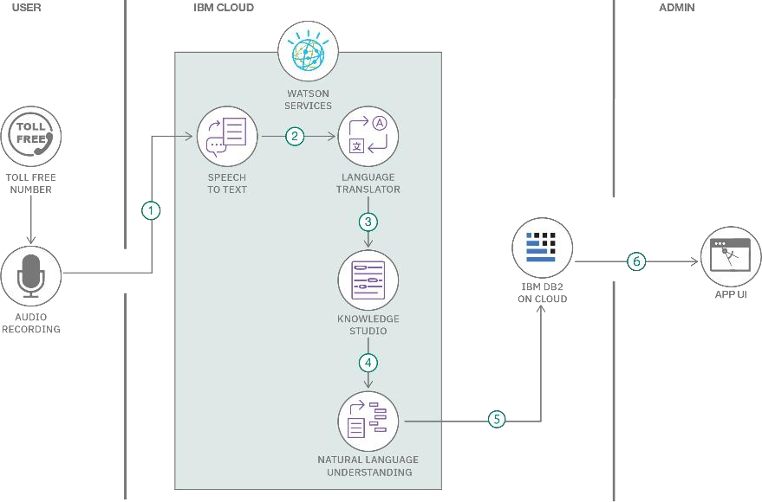

Table-1 : Components & Technologies:

**S.No Component**

1. User Interface

Application Logic-1

4. Application Logic-3

**Description**

How user interacts with application e.g.

Web UI, Mobile App, Chatbot etc.

Logic for a process in the application

Logic for a process in the application

Logic for a process in the application

Data Type, Configurations etc.

**Technology**

HTML, CSS, JavaScript / Angular Js / React Js etc.

2.

Java / Python

3.

Application Logic-2

IBM Watson STT service

IBM Watson Assistant

5.

Database

MySQL, NoSQL, etc.

6. Cloud Database

Database Service on Cloud

IBM DB2, IBM Cloudant etc.

7. File Storage

File storage requirements

1. External API-1
2. External API-2

Purpose of External API used in the application

Purpose of External API used in the application

Purpose of Machine Learning Model

Application Deployment on Local System / Cloud Local Server Configuration: Cloud Server Configuration :

IBM Block Storage or Other Storage Service or Local Filesystem

IBM Weather API, etc.

Aadhar API, etc.

10. Machine Learning Model

11.

Infrastructure (Server / Cloud)

Object Recognition Model, etc.

Local, Cloud Foundry, Kubernetes, etc.

Table-2: Application Characteristics:

**S.No Characteristics**

**Description**

**Technology**

1. Open-Source Frameworks
2. Security Implementations

3. Scalable Architecture

4. Availability

List the open-source frameworks used

List all the security / access controls implemented, use of firewalls etc.

Justify the scalability of architecture (3 – tier, Micro- services)

Justify the availability of application (e.g. use of load balancers, distributed servers etc.)

Design consideration for the performance of the application (number of requests per sec, use of Cache, use of CDN’s) etc.

Technology of Opensource framework

e.g. SHA-256, Encryptions, IAM Controls, OWASP etc. Technology used

Technology used

5. Performance

Technology used

References:

<https://c4model.com/>

[https://developer.ibm.com/patterns/online-order-processing-system-during-](https://developer.ibm.com/patterns/online-order-processing-system-during-pandemic/) pandemic/ <https://www.ibm.com/cloud/architecture> <https://aws.amazon.com/architecture>

[https://medium.com/the-internal-startup/how-to-draw-useful-](https://medium.com/the-internal-startup/how-to-draw-useful-technical-architecture-diagrams-2d20c9fda90d) technical-architecture-[diagrams-2d20c9fda90d](https://medium.com/the-internal-startup/how-to-draw-useful-technical-architecture-diagrams-2d20c9fda90d)